
ROBOT EMBEDDED PROGRAMMING
Lab 3: Introduction to ROS 2 Architecture and Communication Model

FACULTY OF APPLIED SCIENCES AND TECHNOLOGY

Name:
Lance Quan
Michael McCorkell
Percy Sanford
Tyler Brannon

Objective
Introduce students to key ROS 2 components—such as nodes, topics, and services—and get them comfortable with the CLI tools. Students will configure their environment and then explore the Turtlesim demo to see ROS 2 in action.

Step 1: Prepare Your ROS 2 Environment
Follow the official ROS 2 Jazzy tutorial:
https://docs.ros.org/en/jazzy/Tutorials/Beginner-CLI-Tools/Configuring-ROS2-Environment.html
In a new terminal, source the ROS 2 setup file:
source /opt/ros/jazzy/setup.bash
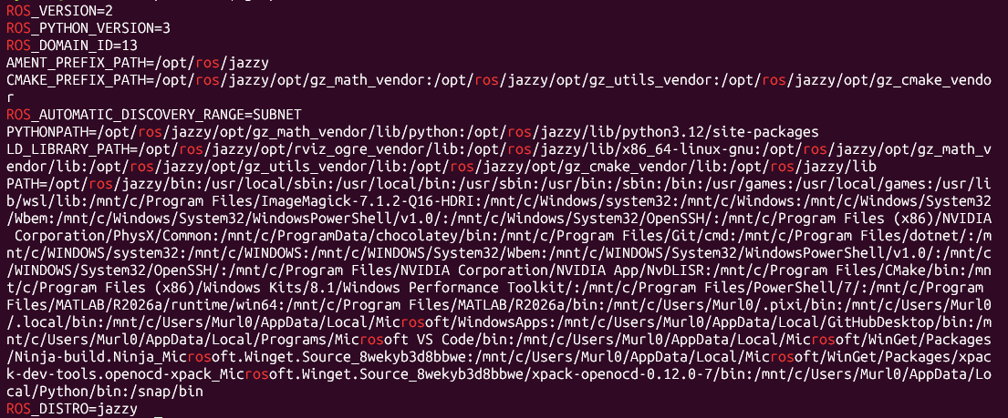
This ensures you have access to ROS 2 commands and tools.

Step 2: Explore Turtlesim
Follow the Turtlesim tutorial:
https://docs.ros.org/en/jazzy/Tutorials/Beginner-CLI-Tools/Introducing-Turtlesim/Introducing-Turtlesim.html
1. Install the Turtlesim package:
sudo apt update
sudo apt install ros-jazzy-turtlesim
2. Confirm installation:
ros2 pkg executables turtlesim
3. Launch Turtlesim:
ros2 run turtlesim turtlesim_node
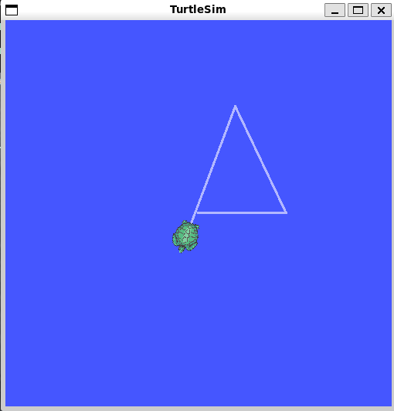
NOTE: If turtlesim window did not show up stop the node with Ctrl + C, then restart it using software rendering::
source /opt/ros/jazzy/setup.bash
export QT_QPA_PLATFORM=xcb
export LIBGL_ALWAYS_SOFTWARE=1
ros2 run turtlesim turtlesim_node
4. In a separate terminal, source ROS 2 again and run the teleop node:
ros2 run turtlesim turtle_teleop_key
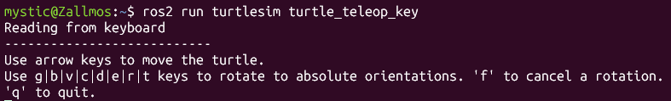
Opps! It is not working…Why?
Use arrow keys to move the turtle and observe how nodes communicate over topics.
NOTE: Make sure that the teleop Terminal is selected for the turtle to move. Resize your windows appropriately.
5. You can see the nodes, and their associated topics, services, and actions, using the list subcommands of the respective commands:
ros2 node list
ros2 topic list
ros2 service list
ros2 action list
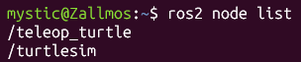
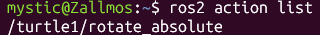
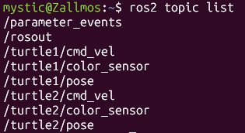

Step 3: View ROS Graph with rqt
Install and open rqt to visualize nodes and topics:
source /opt/ros/jazzy/setup.bash
sudo apt update
sudo apt install '~nros-jazzy-rqt*'
sudo apt install ros-jazzy-rqt
rqt
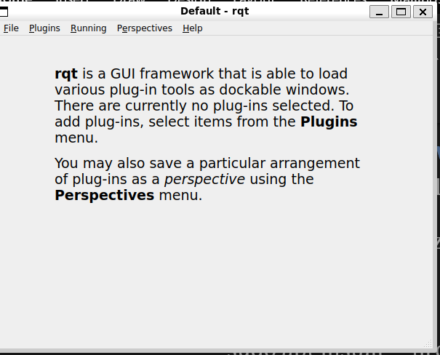
Plugins > Services > Service Caller from the menu bar at the top.
Make sure the turtlesim_node is running
Use the refresh button to the left of the Service dropdown list to ensure all the services of your turtlesim node are available.
Click on the Service dropdown list to see turtlesim’s services, and select the /spawn service.
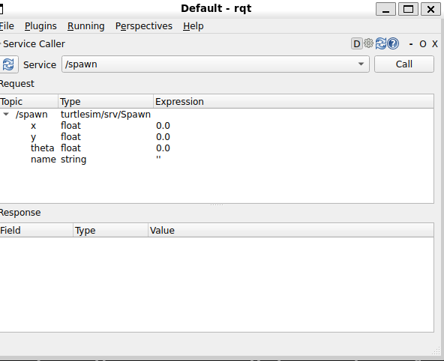
Enter the X and Y values as 1.0 and 1.0 respectively and turtle2 for the name then hit CALL.
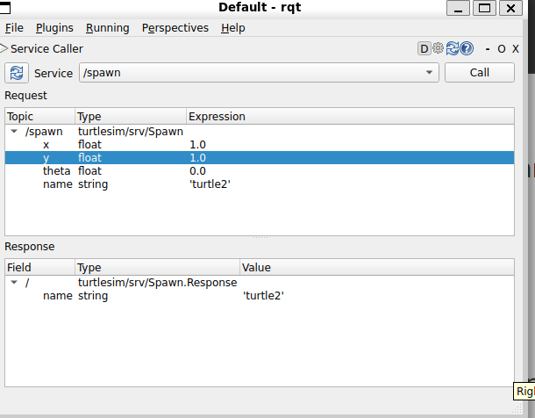
Click refresh.

Try the set_pen service
Now let’s give turtle1 a unique pen using the /set_pen service:
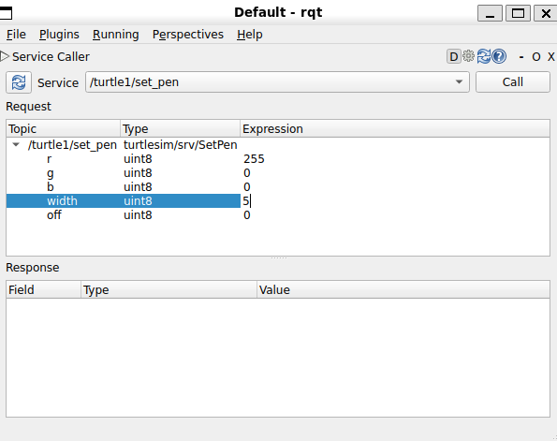
Don’t forget to click CALL
if you return to the terminal where turtle_teleop_key is running and press the arrow keys, you will see turtle1’s pen has changed.
You should see the difference.
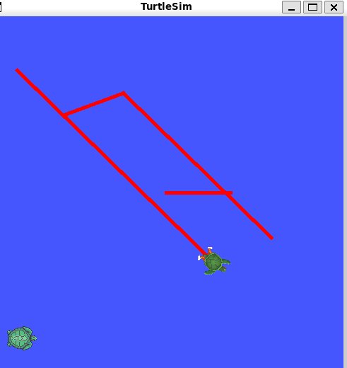

Remapping
You need a second teleop node in order to control turtle2. However, if you try to run the same command as before, you will notice that this one also controls turtle1. The way to change this behavior is by remapping the cmd_vel topic.
In a new terminal, source ROS 2, and run:
source /opt/ros/jazzy/setup.bash
ros2 run turtlesim turtle_teleop_key --ros-args --remap turtle1/cmd_vel:=turtle2/cmd_vel
Now, you can move turtle2 when this terminal is active, and turtle1 when the other terminal running turtle_teleop_key is active.
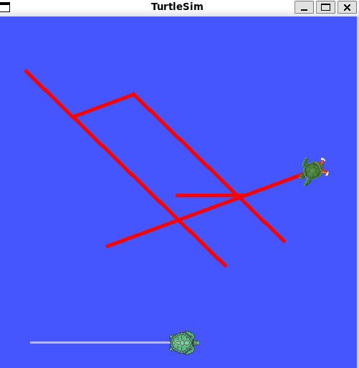

Close turtlesim
To stop the simulation, you can enter Ctrl + C in the turtlesim_node terminal, and q in the turtle_teleop_key terminals.

Deliverables
- Screenshot showing ROS environment variables after sourcing.
- Screenshot of turtlesim_node running.
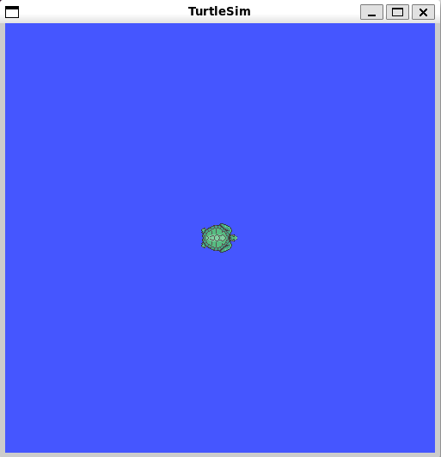

- Screenshot of turtle_teleop_key controlling the turtle.
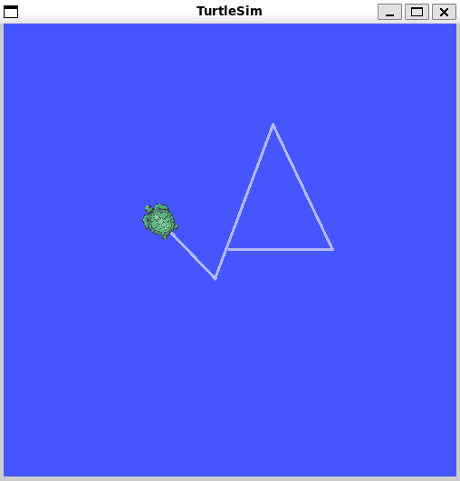

- (Optional) Screenshot of rqt graph showing nodes and topics.
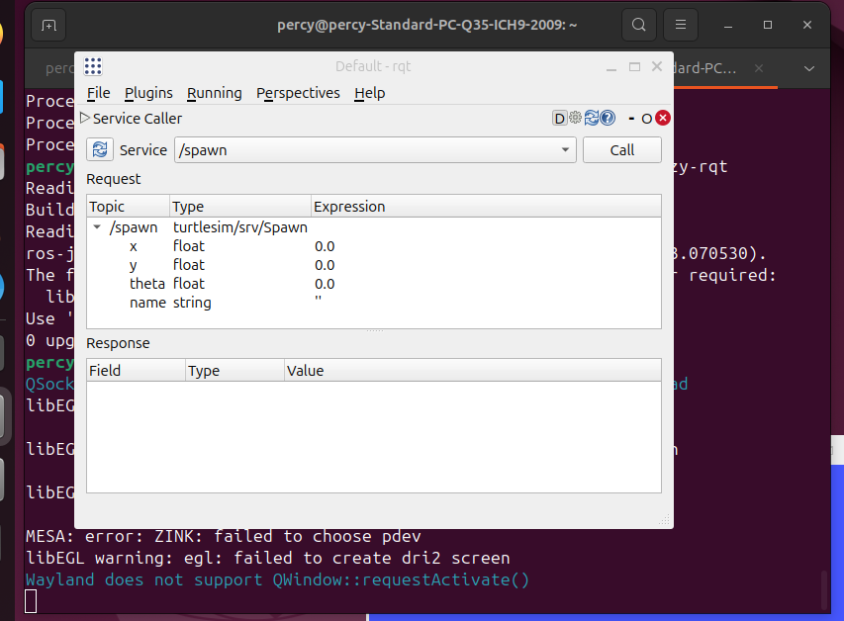
- 2–3 sentences describing what you observed about ROS 2 communication.
In the turtlesim demo, communication between nodes happens through topics using a publish/subscribe model. The `turtle_teleop_key` node publishes velocity commands to the `/turtle1/cmd_vel` topic, while the `turtlesim_node` subscribes to that same topic and updates the turtle's position accordingly. Running `ros2 node list`/`ros2 topic list` made it clear that nodes are decoupled — the publisher and subscriber don't need direct knowledge of each other, only a shared topic name and message type.

